**Assignment -1**

Install Power BI Desktop and share the final screenshot of the report view page which appears when power desktop starts.

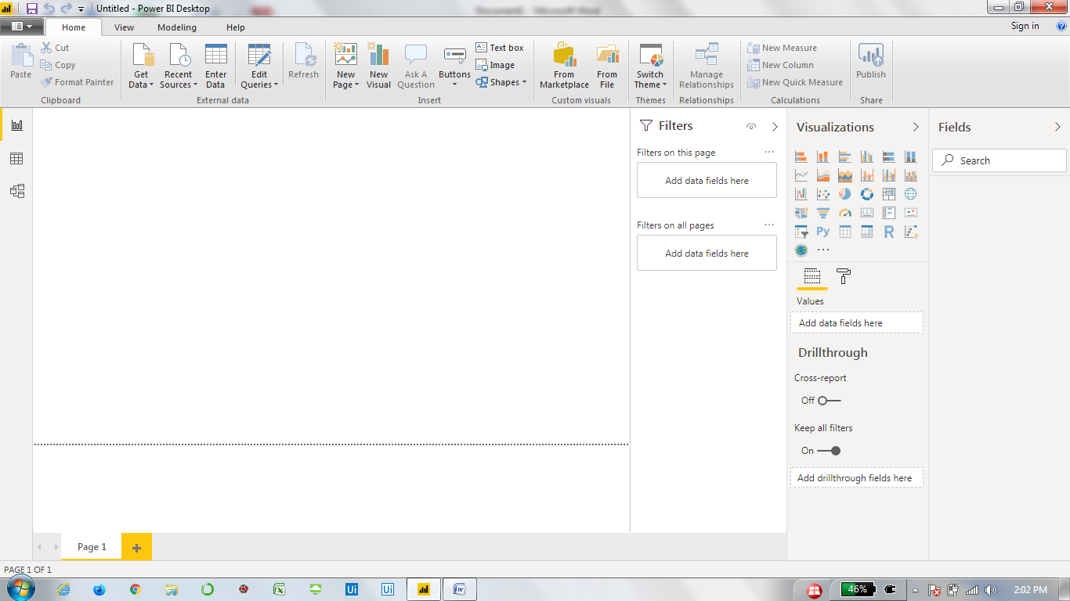

Prepare a document and with the following screenshot

**Report View**

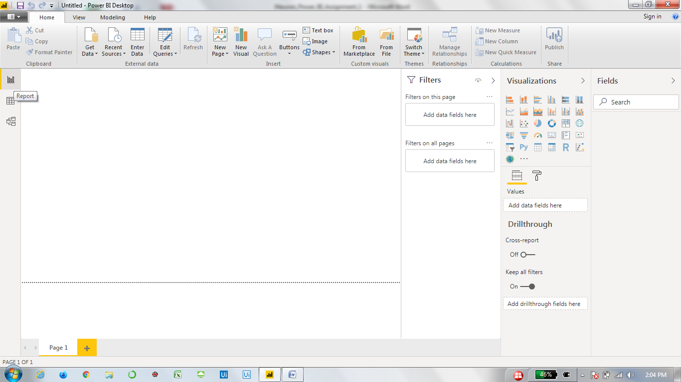

**Data View**

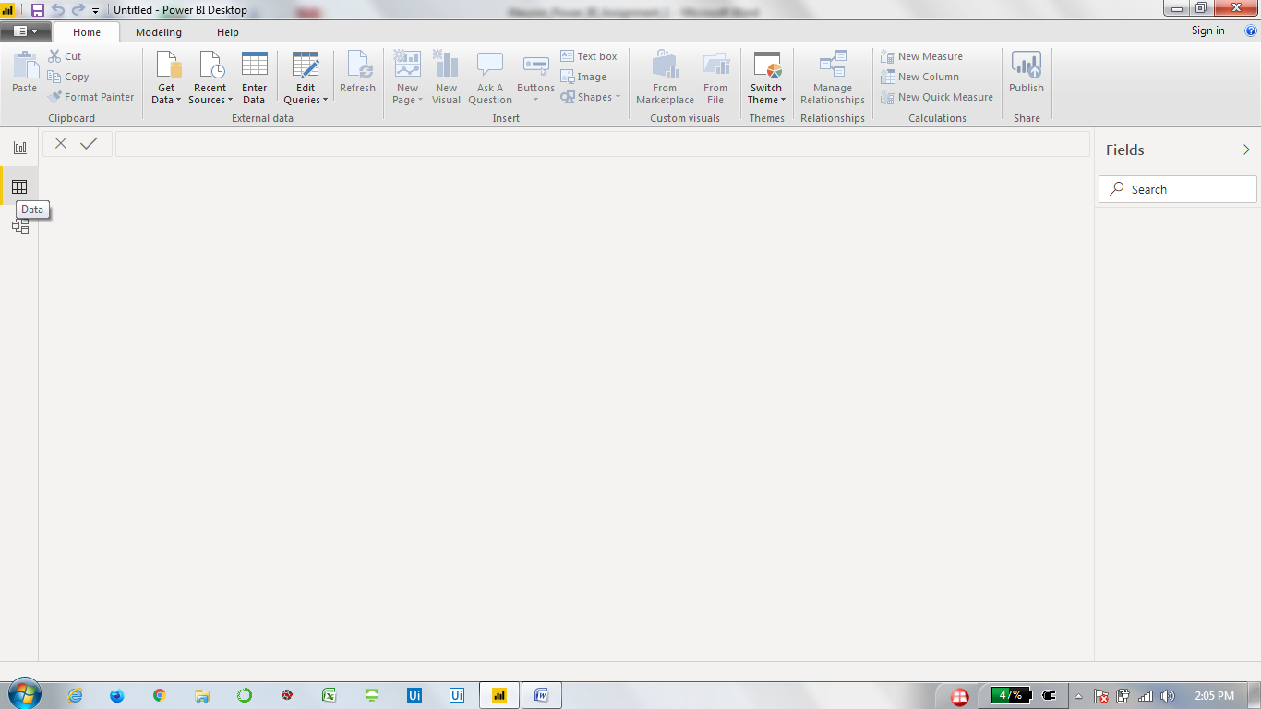

**Model View**

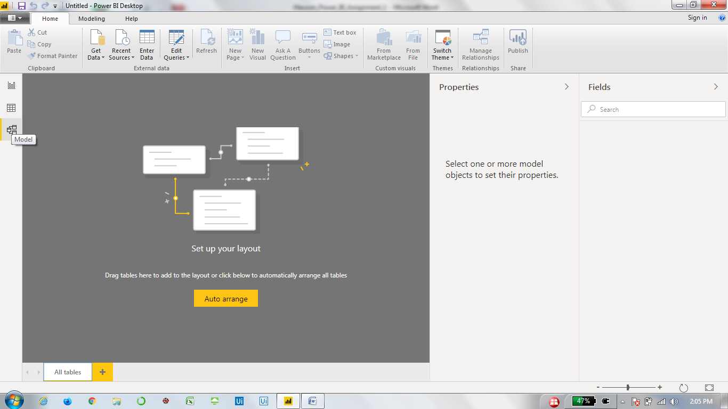

**Power Query Editor**

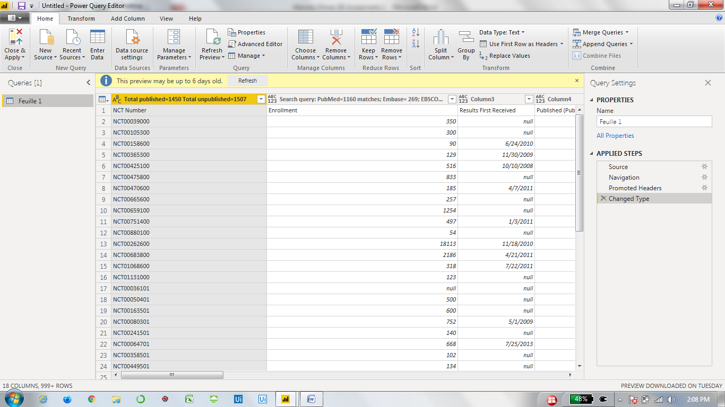

**Advance Editor**

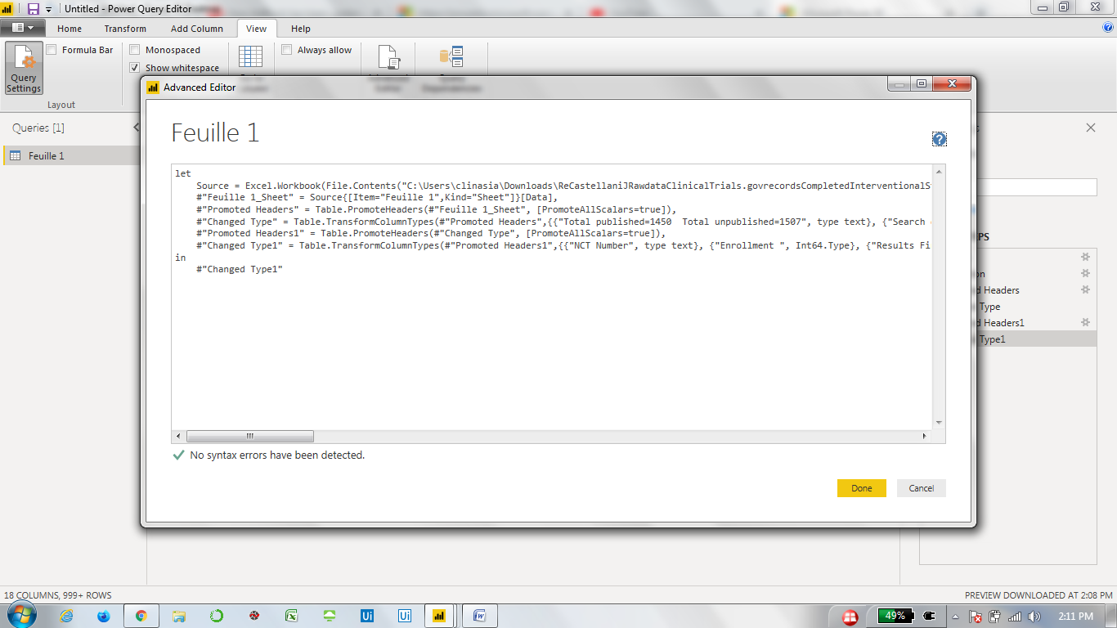

Prepare a document with details of the following along with their price

**Power BI Desktop**

Power BI Desktop is free to use.

**Power BI Pro**

Power BI Pro is charged at Rs. 660 per month for one user.

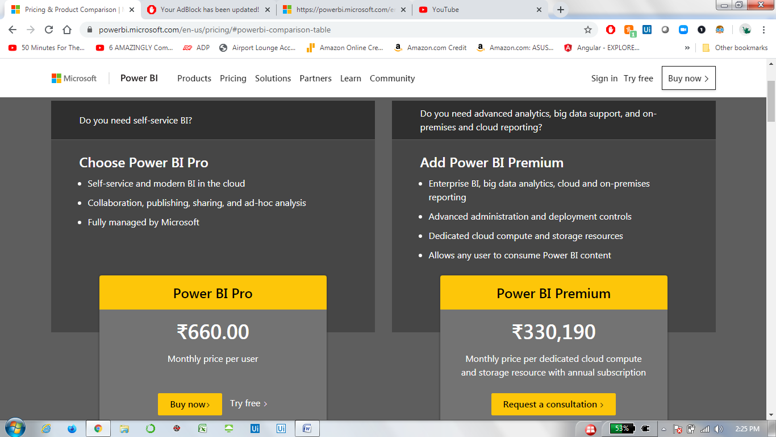

**Power BI Premium**

Power BI Premium is charged at Rs. 3,30,190 per month. As seen in above screenshot.